**MCIS 6333_002 – Data Visualization Programming**

**Fall 2023 Dr. Esther Ledelle Mead, Professor**

**Assignment 2 (A2)** Module 2 12 points

**Instructions**: Work as a team to fill in your team and team member information. Then continue to work as a team to enter responses for each of the three sections: 1) DVs programmed in Python, 2) DVs programmed in R, and 3) Data insights. Do not change the file name of this template except for adding your Team Number and name at the end of "A2-MCIS6333_002" (for example, "A2-MCIS6333_002-Team_1-Bad-To-The-Bone.docx"). Do not remove any content from this template. **Before submission, be sure that all required components are visible on the final version of your file by expanding their edges as needed and by inserting extra space as needed. Be careful not to move around the objects on this document in a way that messes up the flow. As you add content, the items will be pushed down, which is fine, but be sure to not let any DVs get split up or caught in between two pages. Create as many additional pages on this file as necessary. Turning in work created by students/teams from a past semester will result in a score of zero (0) and an official Academic Dishonesty and Integrity Violation report for each team member to the SAU Authorities.**

**Team #: ___1_ Team Name: ________DATAVANA___________________  
   
Team Members (*full names are required*): Contributed effort to this A2? *(Y or N):*  
1. ____REVANTH KUMAR MADASU___ ___Y__  
2. ____ANUSHA PAKKIRU__ _Y____**

1. **Data visualizations DVs programmed in Python that shows change over time based on your team’s Use Case M1 and M2 dataset files**:

**2) Data visualizations DVs programmed in R that shows change over time based on your team’s Use Case M1 and M2 dataset files**:

Insert your DVs below this line.

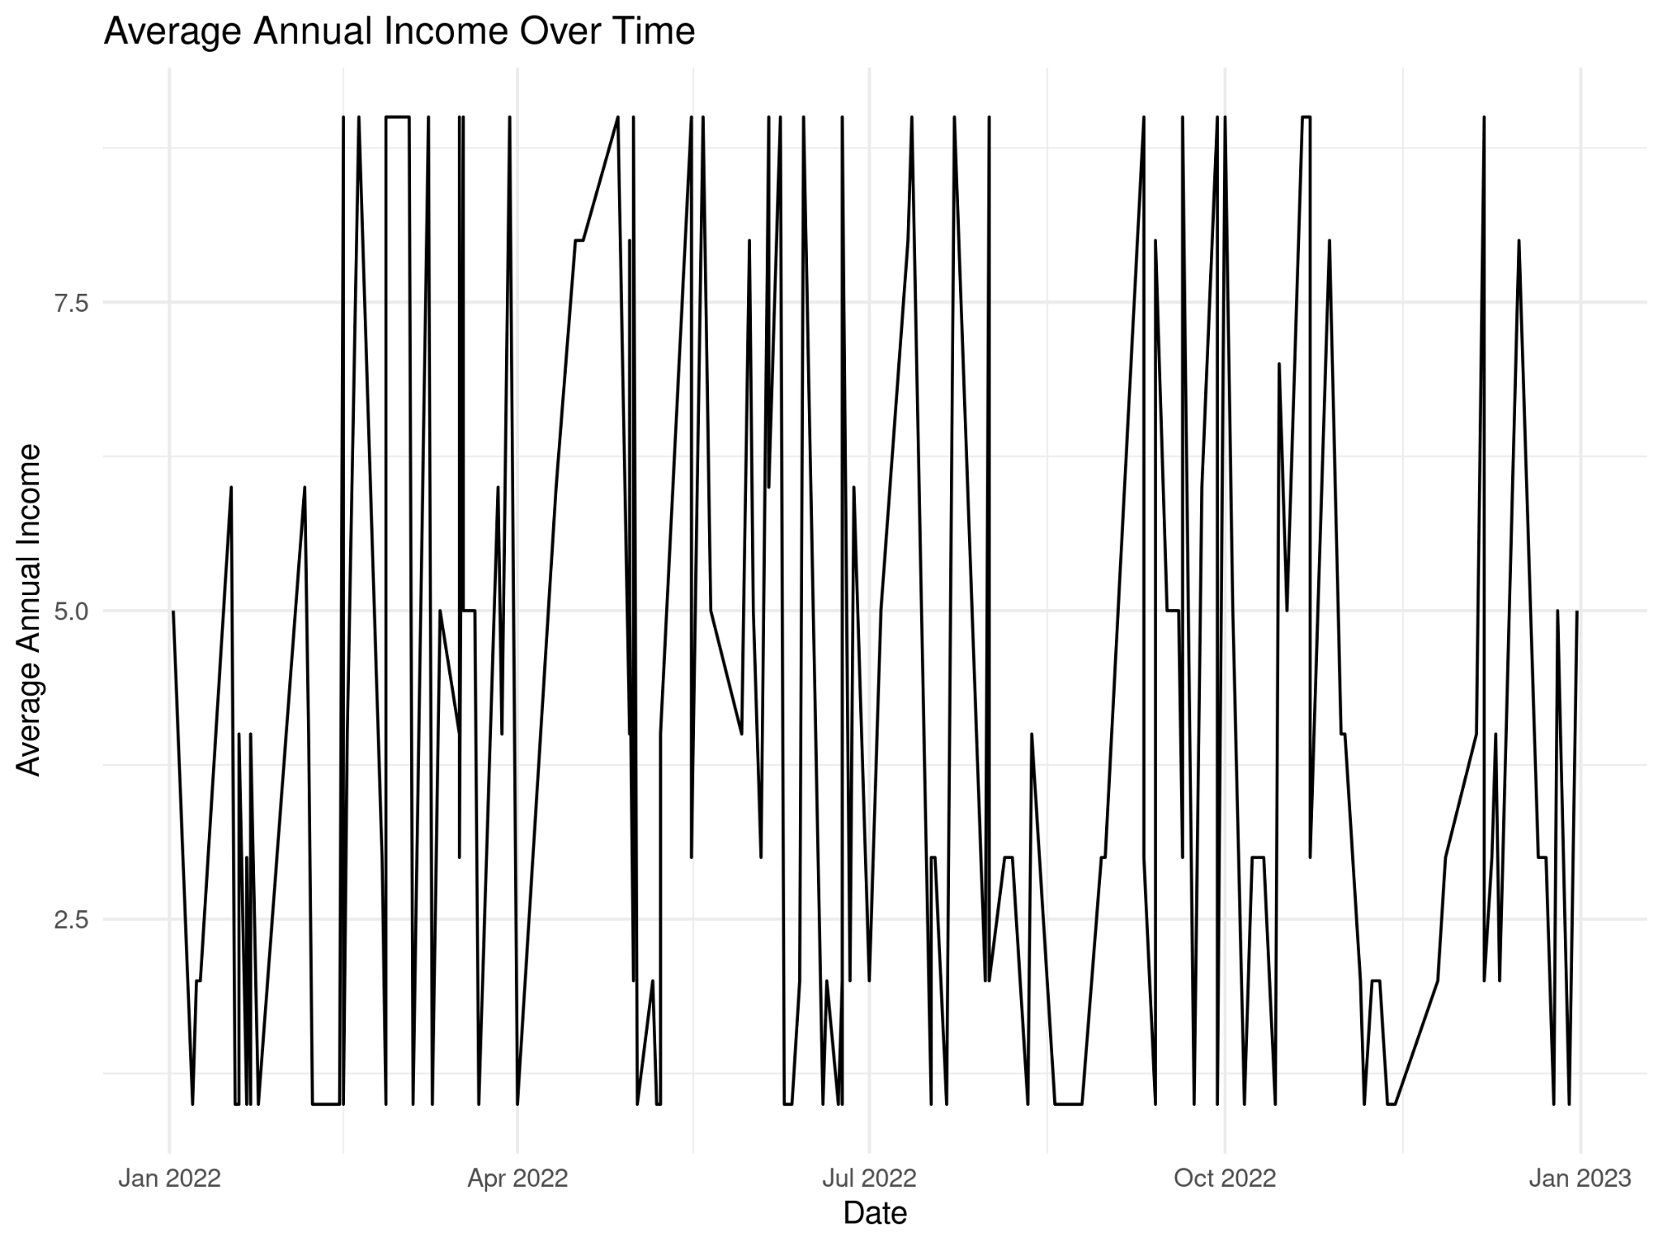

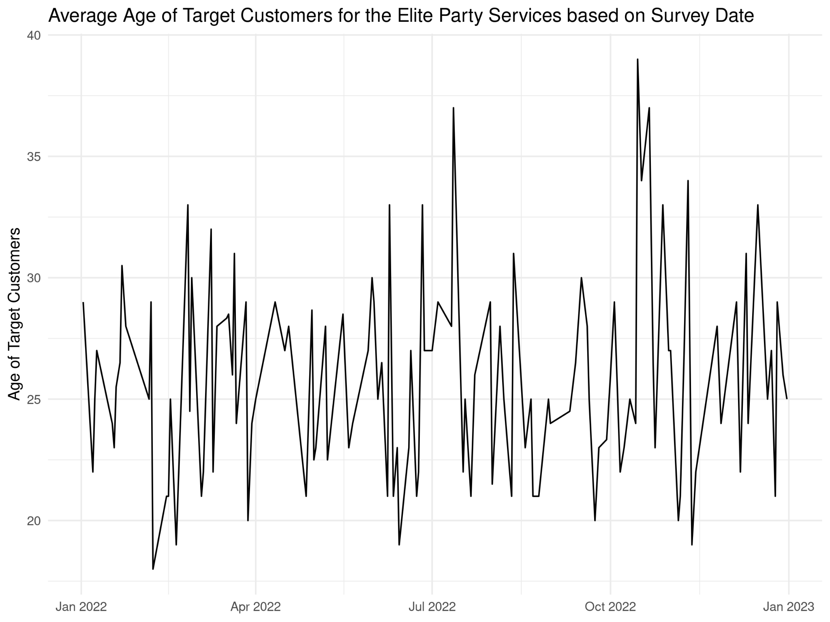

**3) Data insights:**

Below this text instruction line, insert at least three properly structured and arranged sentences (grammar, spelling, sentence casing, use of spacing, symbols and punctuation) to compose some data insights that can be logically deduced from the DVs that you provided above. If you write more than three sentences, be sure to use appropriate paragraphing structure for technical writing[1].

i) As you can see annual income response was slightly decreasing by end of 2022.

ii) The consistency of higher income groups in September and October were less. During that time low income groups were more responding.

iii) Regarding age you can observe there are some spikes in July and October. And the average age was slightly increasing.

iv) During the months of April and May the average age of responders was relatively less.

**MCIS 6333_002 – Data Visualization Programming**

**Fall 2023 Dr. Esther Ledelle Mead, Professor**

1. <https://developers.google.com/tech-writing/one/paragraphs>